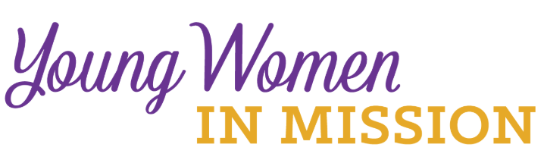
Young Woman Representative Application
Convention (circle one): National District Date: ____________
Convention Location: __________________________
Name_____________________________________ Age ______________
Address _____________________________________________________
City _____________________________ State _________ Zip ___________
Occupation ____________________________________________________
Home Congregation ______________________________________________
Phone _______________________ email __________________________
Please answer the following questions. Use a separate sheet of paper if needed.
Return to your district president.
1) The LWML motto is “Serve the Lord with gladness” (Psalm 100:2). How do you do this in your life?
2) What groups and activities are you involved in or have you been involved in at your church?
3) What do you know about the LWML? Have you been involved at any level?
4) Why do you desire to be a Young Woman Representative for the district?
5) What do you feel your special interests, talents, and gifts are?
6) Will you commit to serve in some capacity in your district after the convention?
Your district is making a financial commitment to send you to the LWML convention.
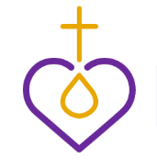
It will be an exciting and spiritually inspiring event with very little free time. You are expected to participate in the full scope of the convention. Are you able to do so?

Please have someone who knows you well, perhaps the person who encouraged you to apply, answer the following question, “Why do you feel this woman would make a good Young Woman Representative?” Have them attach this answer on a separate sheet of paper along with their name and relationship to you.

Please return the application to:
Stephanie L. Meats
17925 St. Marys Road
New Berlin, IL 62670

Or electronically at ywr@lwmlcid.org

Application needs to be submitted by:

September 25, 2020

